Daniel Son

Progress Report 4

Program Summary

**Compiling and Running**

The program is created using FreeGLUT in Visual Studio. Otherwise, it can also be compiled through CSIF using the compile command “g++ main.cpp -lglut -lGL”, and the corresponding display window can be displayed using “Xming”.

**Using the Program**

1. Menu and Display Windows

The program displays an interactive menu window and three separate display windows for orthographic projections. The display windows are labeled by the title of “XY”, “XZ”, and “YZ” for their corresponding projections.

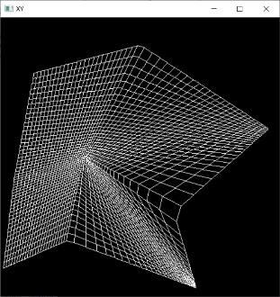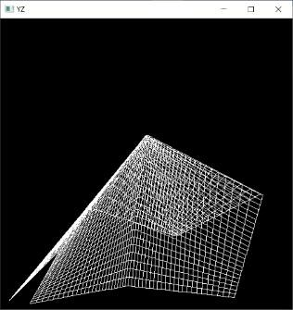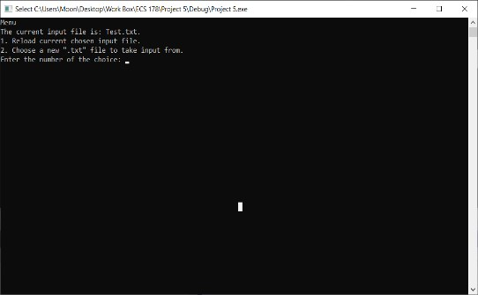

Display Window XY XZ YZ

1. Input Files and Data Management

The program works by taking in input files in the “.txt” format. The default input file is titled, “DefaultInputFile.txt”. It is included in the submission. Any adjustments can be made to an input file by opening the file, making necessary changes, and saving the file. This can be done while the program is running. However, the format must stay consistent. (Explained later). It is recommended that the user edits the file using programs like Excel, because it is easier to visualize.

1. Format for Input Files

This is how “DefaultInputFile.txt” looks when opened in Excel with the exception of color-coded parts. Use it as reference as the format for input files is explained.

\

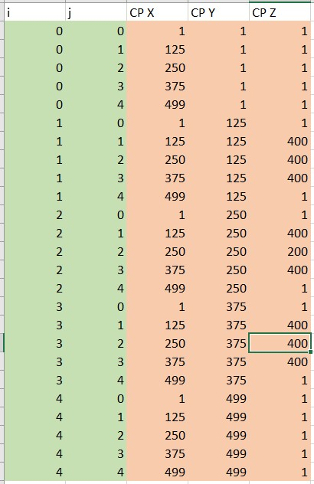

The parts in green are index values for each point to interpolate. For example, an “i” value of 1 and “j” value of 2 refers to point P1,2.

The parts in pink refer to values of the X, Y, Z coordinate of the specified point at “i” and “j”.

There should be one line at the top that serves as a guide line for entering other variables. This should follow the order of “i”, “j”, “CP X”, “CP Y”, and “CP Z” in order of the blocks from left to right.

1. Menu

In the display window, all the relevant data information should be displayed to the user whenever a new graphic is displayed. Furthermore, the user will be presented with a small menu that allows the user to interact with the input files. The user can enter the number of the menu option to select that option.

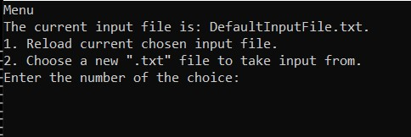

Here’s what each option does:

* 1. Reload current chosen input file.

Reloads the current input text file. Therefore, the user should make changes to the input file, save it, and choose this option to update the graphic.

* 1. Choose a new “.txt” file to take input from.

Allows the user to enter the name of a new “.txt” file that follows the input file format.